Italian growth rate of real GDP, explained by

Inflation and government bond yields

Nagib Stefano Souki

The aim of this work is to analyze the influences that inflation and government bond yields can have on real gross domestic product in Italy, through the Impulse Response and granger causality tests of a Vector Autoregressive Model (VAR). To achieve this goal, the necessary data were collected from database “FRED” of the US Federal Bank in St. Louis, consist of 96 observations at quarterly frequency and cover a period from the first quarter of 1996 to the first quarter of 2020. In the first part of the analysis, we will ascertain the stationarity, to then run a VAR model and all the various diagnostic tests in order to confirm the validity of the model, in order to be able to make the appropriate considerations on the results obtained. What is expected to see is that a change in interest rates of government bond yields or inflation may have a negative effect on the macroeconomic reference variable, GDP.

1. INTRODUCTION

There Is a close relationship between government bond yields, real GDP and price trends. Consider, for example the actions of the ECB. It has an official mandate to keep inflation around 2% and acts on the price level by setting the policy rate. By determining the policy rate, the ECB also helps to determine the prices of government bonds of member countries, with consequences for the resources available for public spending. The interest rates decided by the ECB also influences private investment. These two combined effects therefore have an impact on GDP growth rate. In addition, the prices of a country’s government bonds are linked to the credibility and economic strength of that country, which in turn are linked to the growth rate of real GDP. The purpose of this paper is therefore to model these three variables and to test, given their strong interconnection, whether the time series with quarterly observations of the percentage yields on Italian government securities, implicit GDP deflator influence real GDP in the period

between the first quarter of 1996 and the first quarter of 2020.

1. LITERATURE REVIEW AND THEORETICAL FRAMEWORK

It is often emphasized during more recent economic history (Mervar, 1999) that the economic growth is endogenous result of the economic system. Based on evaluation of regressions performed for many countries (Mervar, 1999) growth was linked with the following economic preconditions: high level of savings and investment, well-educated labour force and other arrangements that allowed abridgement of existing technology gaps. Yet investigating ties between economic growth and the rate of inflation (Mamo, 2012) was also treated as one of the central subjects of macroeconomics research and policy. There is no clear-cut definition about the relationship between economic growth and inflation. There are many controversial issues and findings about this relationship. Different studies (Mamo, 2012) showed that the relationship between economic growth and inflation may be positive, negative and neutral. Sidrauski (1967) suggested there is no relationship between inflation and economic growth. A study conducted by Fisher (1993) shows that the relationship between inflation and economic growth is negative one. Mallik and Chowdhury (2001) found a positive relationship between inflation and economic growth. Today the question is not only is there any relationship between the two phenomena but (Mamo, 2012) which level of inflation can affect economic growth positively or negatively. Barro (1995) stressed the fact that high inflation reduces the level of investment, and such reduction adversely affects economic growth. Mamo (2012) outlines the importance of forecasting of inflation for economic growth. Empirical studies performed to investigate the nature of relationship between inflation and growth indicated: bidirectional causality, a unidirectional causality and no causality between inflation and economic growth. We can also talk about the relationship between government bond yields and real GDP; there is a substantial amount of literature on the determinants of government bond yields. One side of the literature corresponds to the

conventional view that higher government debt-and deficit- to-GDP ratios exert upward pressure on government bond yields (Ardagna, Caselli, and Lane 2007; Baldacci and Kumar 2010; Cebula 2014; Grandes 2007; Gruber and Kamin 2012; Lam and Tokuoka 2011; Martinez, Tercenoa, and Teruelb 2013; Min et al. 2003; Paccagnini 2016; Perovic 2015; Poghosyan 2012). The other side of the literature represents the Keynesian view, which is that central bank’s actions affect the government bond yields, primarily through the effect of the policy rates on short-term interest rates and other tools of monetary policy (Keynes 1930). Although in the General Theory, Keynes ([1936] 2007) addressed the idea that psychological, social and business incentives to investors’ liquidity 7 preferences are also significant factors in determining the interest rate, he still emphasized that there is a direct link between central bank’s actions and interest rates. Following Keynes’s notion of ontological uncertainty and his contention that investors extrapolate the outlook from the present, several studies, such as Akram and Das (2014, 2015, 2017a, 2017b, 2018) and Akram and Li (2017a, 2017b, 2018) demonstrate that short-term interest rates are the key drivers of long-term government bond yields. This body of literature also addresses that the ratios of government debt-and deficit- to-GDP do not have adverse effect on the government bond yields.

1. DATA AND METHODOLOGY

The observations of the series are obtained from the online database “FRED” of the US Federal Bank in St.Louis, consist of 96 observations at quarterly frequency and cover a period from the first quarter of 1996 to the first quarter of 2020. The historical series of gross domestic product at real values is expressed in millions of euros at 2010 values and is seasonally adjusted. The historical series of inflation concerns the rate of inflation with respect to the previous quarter of the same year and is obtained indirectly by means of logarithmic differentiation of the implicit GDP deflator series. The historical series of the yield on Italian government securities with a ten-year maturity is expressed in nominal percentage values and, unlike the other two it is not seasonally adjusted, however since it does not present substantial seasonal variations, this does not cause criticality. The study was carried out using a VAR analysis, in order to understand the causal link between the previously mentioned variables, in

Italy. Basically, the following study was carried out through three different steps, and will be subsequently presented in this sequence:

* check the presence of the unit root.
* check the cointegration between the variables (if necessary).

carry out the VAR analysis.

***Real GDP:*** In the time series expressed in the levels the variances tend to grow as the level of the series causing heteroscedasticity. This can be problematic for ordinary least squares estimators. The problem is however curbed by operating logarithmic transformation on the series in question. Doing so, in fact one obtains a new series with variance approximately constant, without altering the fundamental characteristics of the original series. The series of real GDP shows a clear temporal trend, to avoid criticality a logarithmic transformation is therefore operated, and our analysis will be carried out on the series of the logarithmic transformation of real GDP. Below is shown the graph of the logarithm of real GDP.

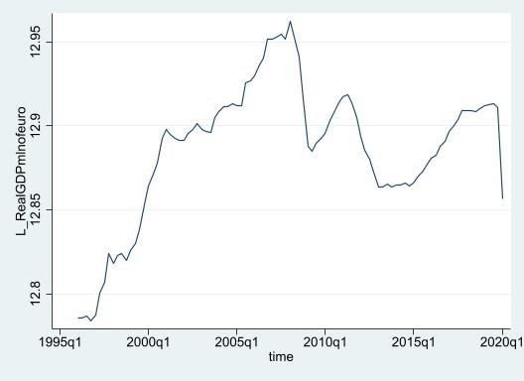

Figure 1: logarithm of real GDP

***inflation*:** Since the implicit GDP deflator series is expressed in levels, for the reasons set forth in the analysis of the GDP series, it is appropriate to work on the logarithm of the series of the GDP deflator. Below is the graph of the logarithm of the series of inflation

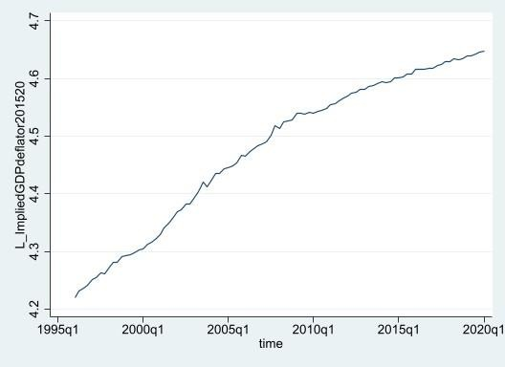

Figure 2: logarithm of inflation (implicit GDP deflator)

***Government bond yields:*** The series of yields on Italian government securities with a ten-year maturity is expressed in percentage values. It is therefore not necessary to carry out any transformation. Below is the graph of the logarithm of the series.

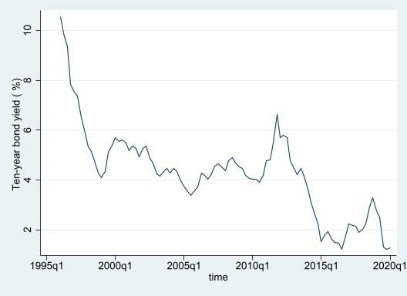

Figure 3: Government Bond yields

1. EMPIRICAL RESULTS AND DISCUSSION
2. *Stationarity*

In order to investigate the stationarity of time series data, the Augmented Dickey-Fuller Test GLS (DF-GLS) was conducted, it modifies to the Augmented Dickey-Fuller test statistic using a generalized least square. We choose to rely on the DF-GLS instead of the normal ADF because it has improved tests and better statistical properties. since, the presence of unit roots, can cause unpredictable results in time series data. Although several tests are available to verify the existence of the unit root, DF-GLS tests are used for this for the reasons mentioned before. The DF-GLS statistics test the hypothesis that there is a unit root in the time series data. These results are presented in Figure 4, Figure 5 and Figure 6. As expected, we reject the null hypothesis that the data are stationary at all significance levels for each series. To make the data stationary, we therefore use first differences, so each data point, rather than being simply the price at time t, Pt, is the price’s change from the previous time period, δPt = Pt − Pt−1

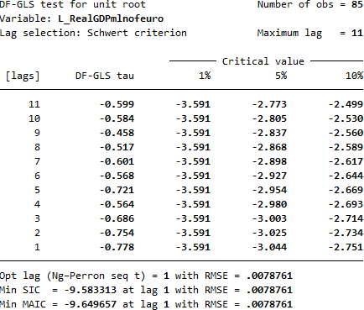

Figure 4: DF-GLS unit root test for logarithm of real GDP

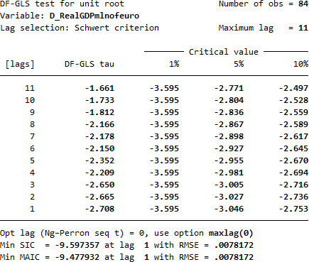

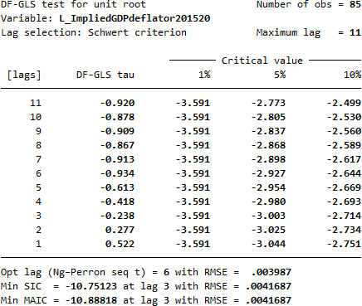Figure 5: DF-GLS unit root test for logarithm of GDP deflator

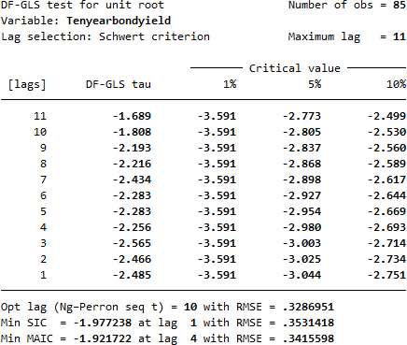

Figure 6: DF-GLS unit root test for Tenyearbondyield

Now we rerun the DF_GLS Statistics for unit root test on the first differences of our time series.

Figure 7: DF-GLS unit root rest 1st difference of real GDP

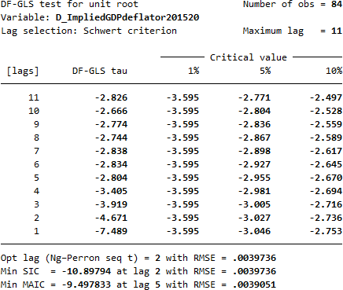

Figure 8: DF-GLS unit root test 1st difference of GDP deflator

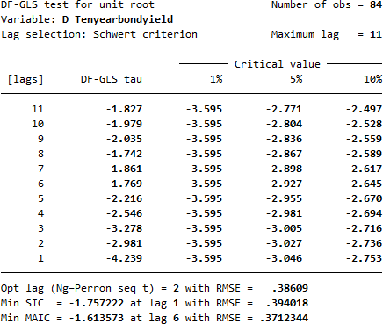

Figure 9: DF-GLS unit root test 1st difference Tenyearbondyield

Now, the data appear to be stationary after applying first differences to our variables. These results are presented in Figure 7, Figure 8 and Figure 9. With the data stationary, in this case there is no need to run a cointegration test since we are interested in the short-term relationship and not the long term. It is possible to put all three-time series into a vector auto regression model (VAR) to test whether the prices and lagged prices of each variable impact one another, thereby implying a form of causality.

1. *Appropriate var length*

To estimate a VAR model, the first thing to do is to choose an appropriate var length (how many lags of each variable should be included in the VAR). As you can see from the table below containing the results of our variables, for each lag length we have different model selection criteria, which are:

* + Log Likelihood → must be maximized
  + Likelihood Ratio → must be minimized
  + Final Prediction Error → must be minimized
  + Akaike IC → must be minimized
  + Hannan-Quinn IC → must be minimized
  + Schwartz Bayesian IC → must be minimize

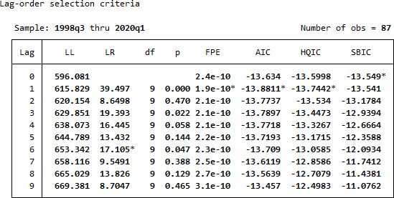

Figure 10: Varsoc lag selection criteria

Taking into consideration all the outputs obtained, as minimum lag at least one year and by following the idea to choose something in the middle, the best lag for this model is 1.

1. *VAR stability*

Once the best model has been chosen, it’s necessary to check if it could return credible results by running diagnostic tests: The first diagnostic test is on VAR stability which returns a table with all the eigenvalues and a graph which represents a unite circle and the roots of the companion matrix.

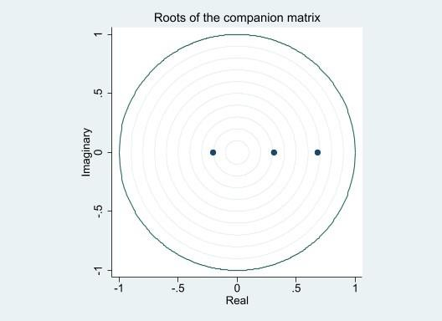

Figure 11: Roots of companion matrix

In this case, as we can see from the following graph, all the eigenvalues lie inside unite circle, so this VAR satisfy the stability condition.

1. *Residual autocorrelation*

Since the most important thing is that the absence of autocorrelation is verified at the last lag, and the null hypothesis tests that there is no autocorrelation at a certain lag, as we can see from the table above, it is not possible to reject the hypothesis of the proposed lag.

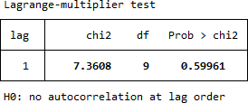

Figure 12: Lagrange Multiplier Test

1. *Normality of the residuals*

A normality test was then performed on the residual series of the estimated VAR. The test used is the Jarque-Bera test, a statistical test for the verification of the hypothesis of normality widely used in the econometric field to determine if the residues are normally distributed. The null hypothesis is a joint hypothesis that both excess asymmetry and excess kurtosis are null, and this hypothesis is rejected for too large test statistic values.

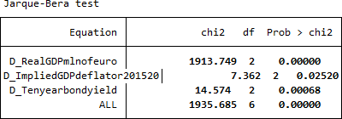

Figure 13: Jarque-Bera test for normality of residuals

As we can see from the results of Jarque-Bera test, all the values are less than 5% (0 or very close to 0) so we reject the null hypothesis of normality of the residuals.

1. *Confirm the lag length*

The fourth diagnostic test is the Wald lag-exclusion statistics, a very important test; it tests the null hypothesis that the endogenous variables at the given lag are jointly zero for each equation and for all equations together (For example: the first lag of the first variable on each regression are jointly zero). Looking at last output of this test in the figure below, we can see how the diagnostic test confirms that the right choice is still to include 1 lag since they are jointly significant.

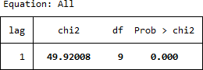

Figure 14: Wald-lag exclusion test

1. *Granger Causality test*

The last diagnostic test is the most important, since already through this diagnostic it is possible to make the first considerations on the VAR model performed relating to its causality (in the sense of a causality measured in the future). To check causality for each equation in a VAR model, a useful tool is the Granger causality test. The idea, behind this test, is that the significance of all the lags of a variable (excluded) are used to hypothesize the causality on the current values of another variable (equation).

The results of the Granger causality test based on the VAR results are presented below and suggest fairly clear evidence that the time series do not impact one another. The only exception is inflation effect on growth rate of real GDP, and the first lag of the growth of GDP on itself.

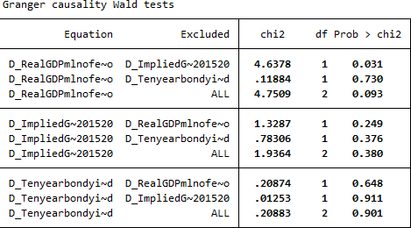

Figure 15: Granger causality test

1. *VAR results*

# 1st equation growth rate of real GDP:

As we can see from the results of VAR in appendix A, the coefficient of the first lag of GDP growth rate is significant and positive, as if the coefficient of the first lag of inflation both also confirmed with the granger test, the coefficient of the first lag of the series interest rates changes is on the other hand not significant according to var and granger test provides evidence in the same direction. This result is unexpected considering the close relationship between interest rates and economic trends of the economy.

# 2nd equation inflation:

According to VAR results, no coefficient excluding the constant Is significant. The granger test also provides evidence in the same direction none of the lags of any of the three variables including inflation itself, significantly improve the prediction of the other. That even the coefficient of the lag of inflation itself is not significant is strange. It provides evidence in favor of the hypothesis that inflation is exogenous to the model.

# 3rd equation Ten-year bond yield series:

The results of the Granger test confirm the evidence provided by the VAR results, the only coefficient that is significant is that of the term of the first delay of the series of the difference of the yields itself.

1. 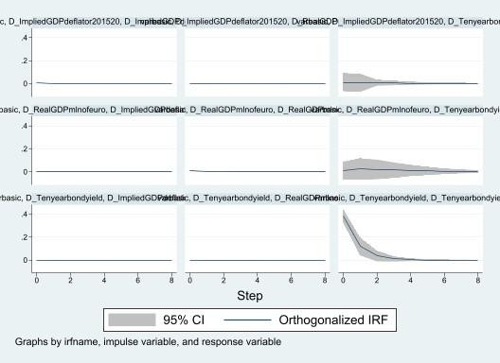*Impulse Response Function*

Figure 15: Impulse response function graph

A shock in inflation has a positive effect on the GDP growth rate, on the other hand a shock in inflation has a non- significant effect on the series of yields. The effect of a shock in the GDP growth rate series is not significant on either the series yields and inflation. Similarly, a shock in the yield series has no significant effect on either the GDP growth rate series or the inflation series

1. *Conclusions*

Looking back at all our empirical results of all the tests that we have done during this research we can conclude that inflation is exogenous to the model, not even its lags are significant. In the regression of differences in returns (difference of yields) the coefficients of inflation and GDP growth rate are not significant, at last from the regression of GDP growth rate we obtain two regressors with significant coefficients, which are the first lag of inflation and the first lag of the GDP growth rate. In conclusion the only significant relationship observable in the model is a positive correspondence between changes in the series of inflation at time t-1 and the GDP growth rate in the subsequent period t.

APPENDIX A

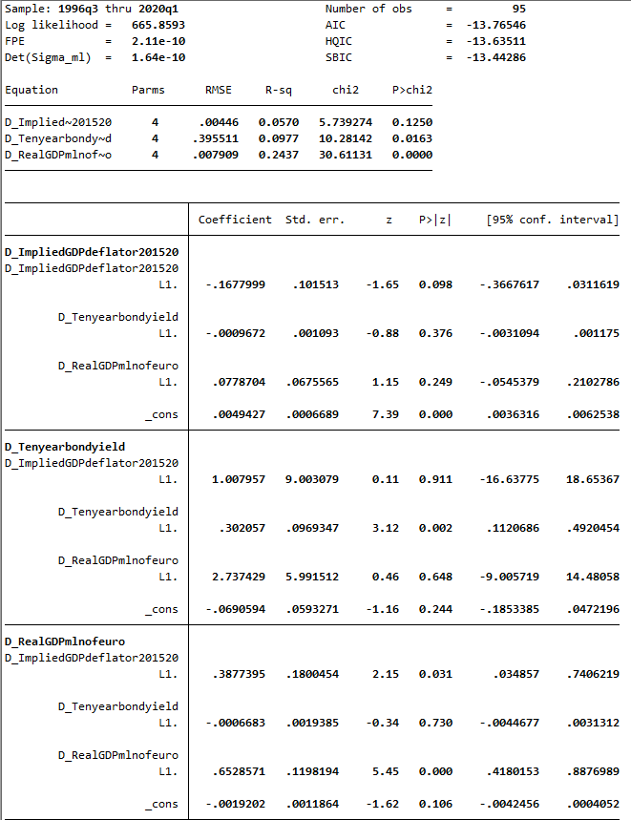

REFERENCES:

* SIMS C. A. Jan. 1980. Macroeconomics and Reality. Econometrica Vol. 48, No. 1 (Jan., 1980), pp. 1-48.
* Barro, R. J., 1995. Inflation and economic growth. NBER Working Paper No. 5326.
* Barro, R. J., 1997. Determinants of economic growth: a cross-country empirical study. NBER Working Paper 5698
* Andolfatto, D., 2005. Macroeconomic theory and policy.

Simon Fraser University, Burnaby.